Chapter 3, Problem 26.

Calculate the node voltages v₁, v₂, and v₃ in the circuit of Fig. 3.75.
3 A
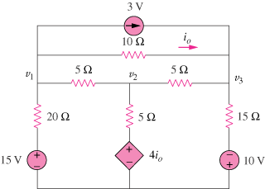

Figure 3.75
For Prob. 3.26.

